**UNIVERSITY OF WATERLOO**

Faculty of Mathematics

**Version Control System in Workplace**

Monica Bastianpillai

BMO InvestorLine

100 King St W

Toronto Ontario

M5X 1H3

Prepared By

Gibson Wong

2A Computing and Financial Management

ID 20484836

April, 2014

**Memorandum**

To: Monica Bastianpillai

From: Gibson Wong

Date: April 15, 2014

Re: Work Report: Version Control System in Workplace

I have prepared the enclosed report, “Version Control System in Workplace,” as my 2A work report for the eBusiness Department at BMO InvestorLine. This report, the second of four work reports that the Co-operative Education Program requires that I successfully complete as part of my Bachelor of Computing and Financial Management Honors degree requirements, has not received academic credit.

The eBusiness team provides constant updates and improvements to two of BMO InvestorLine’s websites: Self-Directed and adviceDirect sites. As an eBusiness Specialist, my roles include daily, weekly, as well as monthly updates towards the website. Furthermore, I was responsible for providing monthly analytics reports that summarize clients’ interaction within the website. Occasionally, I take on new tasks like creating wireframes and developing new web pages. This report is an in-depth analysis pertaining to the company’s web development process as well as possible improvements.

The Faculty of Mathematics requests that you evaluate this report for command of topic and technical content/analysis. Following your assessment, the report, together with your evaluation, will be submitted to the Math Undergrad Office for evaluation on campus by qualified work report markers. The combined marks determine whether the report will receive credit and whether it will be considered for an award.

I would like to thank you for your assistance in preparing this report.



**Table of Contents**

List of Figures and Tables………………………………………………………………..ii

Executive Summary……………………………………………………..………………iii

1.0 Introduction……………………………………………….……….…………….1

2.0 Analysis……………………….………………………………………………….2

2.1 Overview of version control …………………………………………...….3

2.2 Different type of version control …………………………………………5

2.3 Comparison of each version control ……………………………..………6

3.0 Conclusion………………………………………………………………..………7

4.0 Recommendations………………………………………………………….…….8

References………………………………………………………………………..………..9

**List of Figures and Tables**

Figure 1. Model for the copy-modify-merge process ………………………………..4

**Executive Summary**

The main responsibility of the eBusiness department of BMO InvestorLine is to maintain their websites with the most recent information while offering a wide variety of enhancement to their clients. As a result, improvement on the maintenance process could greatly increase the efficiency and quality of the contents of the updates. This report focuses on a new tool known as version control system and analyzes how the eBusiness team can take advantage of it

There are two different kinds of version control system: centralized and distributed version control. Centralize version control hosts the project at a central location, normally within server. Distributed version control allows each individual to have a copy of the project as well as permission for individuals to perform updates. Version control system improves the maintenance process in various ways:

* Both centralized and distributed version control provides a full history of updates and allows developers to compare code to past update.
* Both version control automate the updating process through simple commands
* Distributed version control improves the ability to branch off and merge code
  + Merge: allows multiple developers to work on the same code at different times and merge their code when needed.
  + Branching off allows teams to create different updates without affecting the original project.

This report recommends BMO Investorline to implement a distributed version control system.

1.0 Introduction

The growing demand for dynamic web applications has driven an increase in new JavaScript web framework. The most popular type of framework follows an architect pattern called Model-View-Controller (MVC). This pattern addresses the issue of separation of concerns by splitting up the problem into three components: the model which contains the data, the view which contains the display and the controller which glues the model and view together. As this architecture helps solve various problems, many frameworks are beginning to implement the MVC pattern.

The increase in different frameworks has also led to a popular, yet never ending debate in finding the best framework. Although there is no concrete answer, comparing the different frameworks available will yield important findings. In this report, we will compare two popular frameworks, Backbone.js and AngularJS; the former of which is currently used by S&P Capital IQ. Firstly, we will provide a broad overview of the two different frameworks. We will then analyze the benefits of switching from Backbone.js to AngularJS. Finally we will provide solutions and methods to overcome the drawbacks that might occur from the migration.

2.0 Analysis

Both Backbone.js and AngularJS have been around for the same amount of time. However up until the beginning of 2013, Backbone.js was the more popular weapon of choice. As the year 2013 rolled in, Backbone.js received less activity while a huge interest for AngularJS occurred. Why did major shift in interest occur and should our company follow this trend?

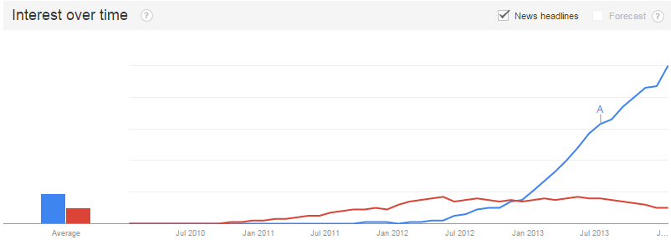

**Figure 1**. The above indicates a relationship between framework interest and time where AngularJS is represented with the color blue while Backbone.js with the color red

As previously mentioned, many web application frameworks now a day follow the MVC pattern. Both Backbone.js and AngularJS implements if not closely, a variation of this pattern. In essence, each framework has their own idea on how to organize models, views and controllers. These different ideas are the key criteria in creating a unique framework and are the reason behind the intense debates found online.

2.1.0 Backbone.js

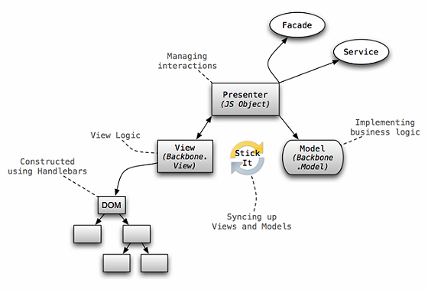To start off, Backbone.js is a small JavaScript framework that provides the basic tools to structure the MVC pattern. It relies on the Underscore library and often times, the jQuery library in order provide a complete platform for building web applications. Despite being the small framework that it is, Backbone.js offers a good set of conventions to help structure the code properly. This is done through the event-driven communication between Backbone’s model and views. One can attach an event listener to an attribute from the model and reflect the changes onto the view. Because of the lack in Backbone controllers (since Backbone views act as both views and controller), many programmers recognize Backbone.js as a framework that follows the Model-View-ViewModel (MVVM) pattern. Regardless of the title of the pattern, Backbone.js provides a respectable solution to organizing large and complex JavaScript code.

**Figure 2**. The above illustrates how models and views are incorporated to produce the web application in Backbone.js. Notice how Models and Views are synced using a third party library. This can be replaced by manually syncing up models and views using Backbone’s ‘listenTo’ method.

Another core feature of Backbone.js is that it is a small and minimalistic framework. This provides a lower learning curve for the user and at the same time, allow for clean and organized code. Furthermore, developers have the freedom to create and wire up their own components to their liking. If there are problems that cannot be solved with the Backbone framework alone, programmers can easily create their own plug-ins or include a third party library. That being the case, developers are often required to create the architecture and wiring themselves, which in the end, is time consuming and requires good attention to writing clean code.

2.1.1 AngularJS

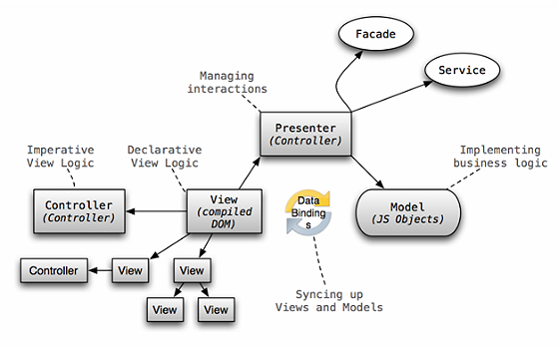On the other hand, AngularJS is a larger framework that was built to relief the problem of tightly coupled code between declarative programming with imperative programming. To understand the differences, imperative programming can be thought as “how to do something, and what you want to happen” while declarative programming can be thought as “what you would like to happen”. In Backbone.js, both of these programming styles are incorporated in the Backbone view. As a result there is a tight coupling between the DOM manipulation (manipulation of web elements) and the business logic. AngularJS solves this issue by enforcing declarative programming into angular directives and imperative programming into angular controllers. As a result, there exists a clear separation between the presentation and the data. Furthermore, AngularJS was created to encourage developers to follow a test-driven development process. In other words, developers should always think of different test cases first, before diving deep into writing code.

**Figure 3.** The above illustrates how models and views interact with each other to produce the product using AngularJS. Notice the subtle differences in between the Backbone’s and Angular’s model

Unlike Backbone.js, AngularJS is extremely opinionated and requires developers to follow Angular’s way of development. Many programming practices derived from Backbone.js cannot be applied for development with AngularJS. For instance, creating user interface with JavaScript (often done by Backbone.js developers) is frowned upon when using AngularJS. As a result, a much steeper learning curve is required.

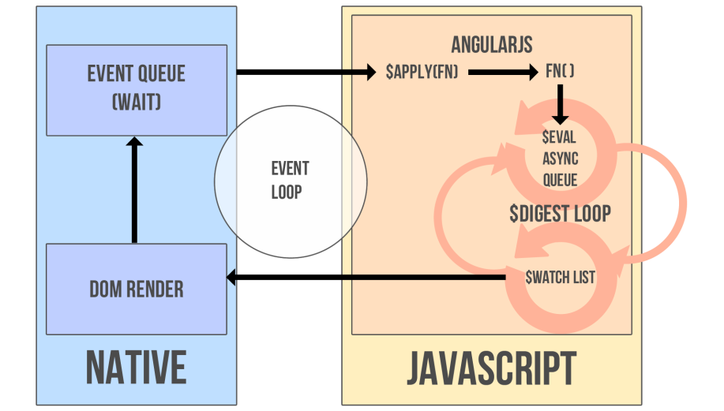The syncing between models and views are also quite different when comparing Backbone.js with AngularJS. Instead of listening to changes from the model and the view, AngularJS has a built in data-binding system. AngularJS does this by extending the regular web flow by adding its own event loop, called the digest loop. It then identifies all bindings in the code and adds them into a watch list. The bindings are resolved (using a method called dirt checking) when the digest loop runs and any changes found are updated in the respective model or view. Since changes from the model can update the view, and vice versa, this method of data-binding is called two-way data-binding.

2.2 Advantages of switching frameworks

There are numerous advantages that can be gained from switching from a Backbone.js framework to an AngularJS framework. To begin with, AngularJS’ includes a large API that can be used to help simplify common tasks of a web application. For instance, loading a list of data and filtering them in real time can be done in one line (using Angular directives like ng-repeat and ng-filter). Being able to filter data in real time is also an impressive feature and is easily created by using Angular’s two-way data-binding system. In order to do the same thing, Backbone developers will need to attach event handlers (like on key up) to input boxes as well listeners to the model to listen to changes. Furthermore, each listen or change requires get and set functions respectively. This entire process is quite tedious since it is required each time a developer wants to sync up the model and the view.

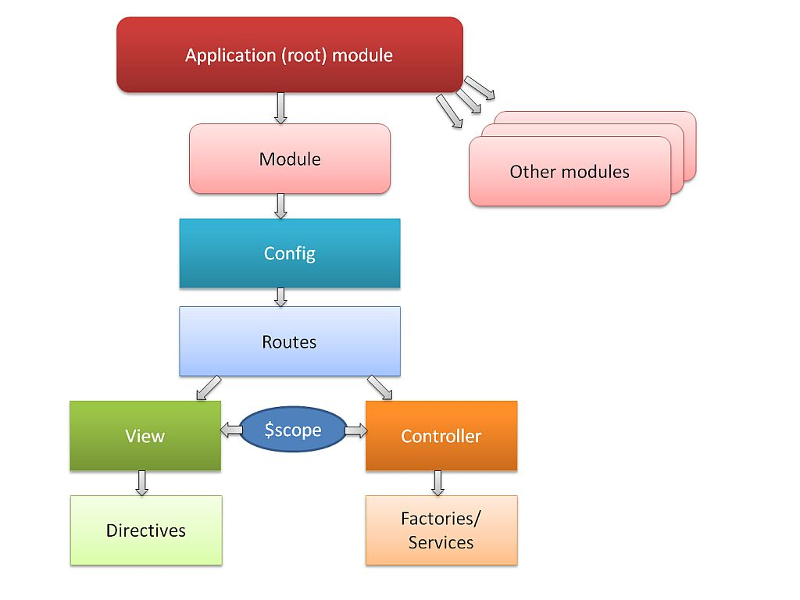 Furthermore, the overall structure using AngularJS is reasonably clean and readable. This is because each component can easily be fit in the following types: Views (templates), Controllers, Factories, Services and Filters. Each of these can then be tested individually and re-used whenever necessary. On the other hand, Backbone.js only provides View, Model (Collections are similar to Models) and also depends on Underscore’s templating engine. Most of the logic are focused heavily on Backbone Views, and as a result, hinders the ability to re-use code.

**Figure 5.** The above is the general components that builds up and Angular application. Notice that the root node (Routes) between view and controller is just a special Directive created by the AngularJS framework

Finally, the most important benefit that can be gained from AngularJS is that it enforces developer to write test-driven code. The ability to test individual modules (this process is called Unit-Testing) allows developers to gain confidence whenever editing existing code. This is especially useful in the case for large-scale project as many developers will be making changes to the project regularly. The ease in unit testing in AngularJS is created by a method called dependency injection. Each unit in the project is highly decoupled, separate from other modules and can be tested individually. In the event that modules depend on one another, testing can be done simply by injecting modules together.

2.3 Overcoming the difficulties

Although there are many advantages of AngularJS, switching frameworks can also yield some difficulties. As previously stated, AngularJS is a framework with a steeper learning curve. Switching from Backbone.js to AngularJS requires each developer to learn the new frameworks and adapt to the new programming styles. That being said, the growing community for AngularJS is an asset for developers in the event that they reach a difficult problem. However, once developers are familiar with this framework, an increase in productivity can be seen. Since much functionality are built into AngularJS, developers can save time writing tedious boilerplate code and spend more time creating features. The amount of time spent bug fixing will also be reduced as each modules are tested before making changes to the project.

As the programming practices between the two frameworks are quite different, migrating code will take a decent of time. Furthermore, things that are originally done in Backbone.js may not be the same as AngularJS. For instance, Backbone.js prefers rendering template and nest views to create the UI. AngularJS does not have a concrete way of doing this. Instead, this framework prefers to use one single view and is rendered automatically on Angular’s bootstrapping process. That being said, it is not impossible to nest views in AngularJS. The solution to this problem is to create angular directives. These directives act as templates and can provide added functionality. As a result, we can create one view and have nested directives which acts similar to Backbone’s nested views. Furthermore, this solution follows well with AngularJS’ coding practice to allow each unit (in this case, directives) to be easily tested. To see a concrete example, view Appendix 1. Another major difference between coding practices of the two frameworks is the ability to integrate third party library. Since Backbone.js is small and flexible framework, integrating third party library is very easy. For example, S&P Capital IQ relies on libraries like jQuery, slickgrid, Moment.js and many more. On the other hand, using third party library in AngularJS is much more difficult. These third party libraries will need to be converted into angular directives or services keeping testability in mind. Furthermore the amount of third-party library for AngularJS is much smaller than Backbone.js. However, this is not entirely a major concern as AngularJS is capable of replacing many libraries commonly used in Backbone.js. For instance, many functionally from the jQuery library are already a built in feature of AngularJS. The diagram on the side illustrates some of the common jQuery commands that are replaced by AngularJS. An example of incorporating jQuery into Angular can be found in Appendix 2

3.0 Conclusion

With so many frameworks available, web applications are evolving to become more interactive and more dynamic. Given each framework is distinct from one another, analyzing the benefits and downfall it comes with is always extremely important. Backbone.js is a lightweight framework giving developers the basic tools to create good structure and foundation for clean and organize code. It furthermore allows developers the freedom to build upon the framework through a wide variety of third party libraries. As a result, small applications can be easily whipped up and maintained to your own liking. AnuglarJS, on the other hand, limits developer’s programming choices to follow the conventions provided by the framework. With the added ability of two-way data-binding, developers no long need to manually sync the model and view together. By forcing developers to split up large problems into decoupled and maintainable code, testing solutions has become easier than ever.

As the intense debates for the greatest framework continue, one can only question if an answer will ever exist. Instead of blindly following the trend, developers should pool in time to carefully research and analyze the frameworks that are best suited for situation. Each framework will have its own benefits and downfalls. The ability to adapt to these changes is the key in finding the most appropriate framework for the project.

4.0 Recommendation

The PortfolioRisk division of S&P Capital IQ is currently using Backbone.js as its main front-end framework. Using Backbone, the team is able to build the product and implement features extremely quickly. As the project continues to expand, maintaining the solution has become a major issue. Constant time and effort is set in place to fix bugs as well as re-factor code to increase quality. Using AngularJS will be able to solve these problems as it enforces developers to constantly test their code. In addition, implement features is much easier since two-way data-binding automatically syncs up models and view.

Although implementing AngularJS for the front-end framework will be extremely beneficial to the company, I currently would not recommend this change. Instead, I would recommend further research and proper training before diving into to the migration. Since the current team is focused on juggling between bug fixes, code re-factoring and features implementation at the same time, migrating frameworks right now can be quite dangerous. Only when the company has decided to slow down on pushing out features, should the team considering switching frameworks.

Appendix 1: Nesting Views

Using HTML as templating engines, the following are the individual views used for nesting

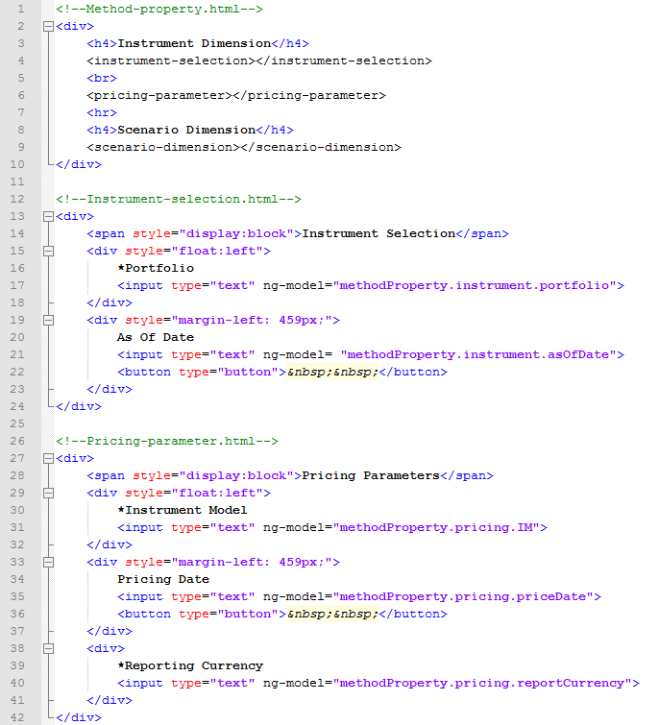

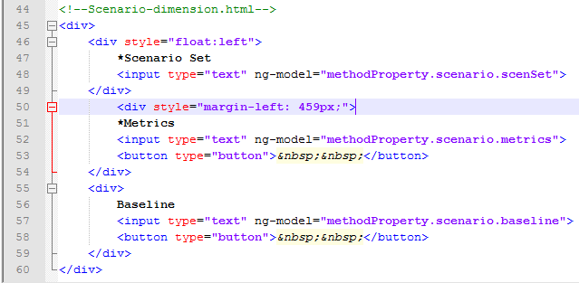

Unless extra functionalities are needed, the following is the code to define the instrumentSelection directive. Other directives are defined similarly.

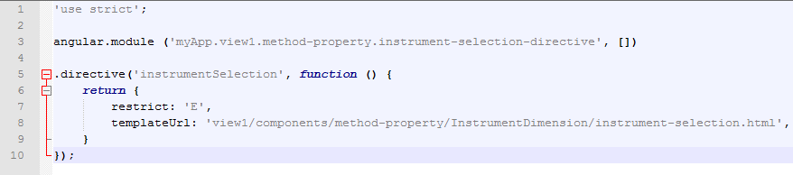

Inject all the directives together in the parent module.

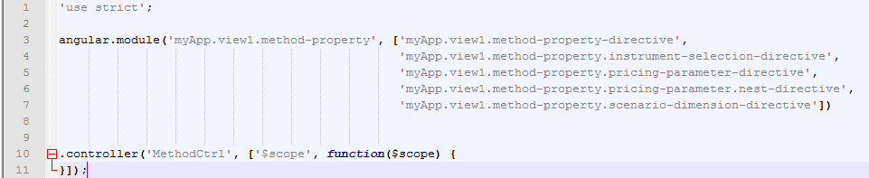

Appendix 2

Code for creating the r2Dialog directive

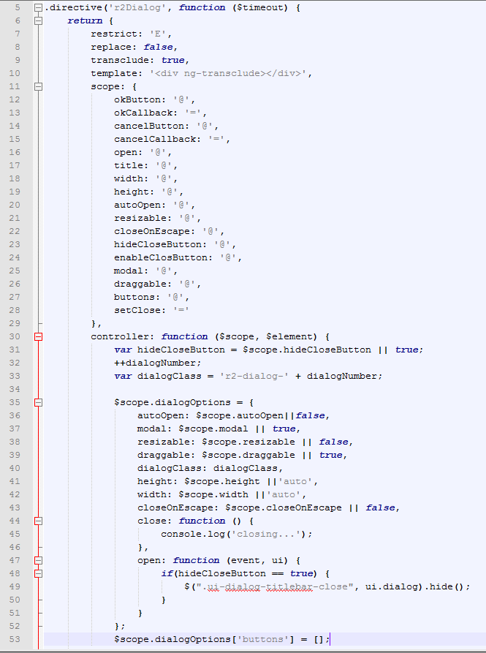

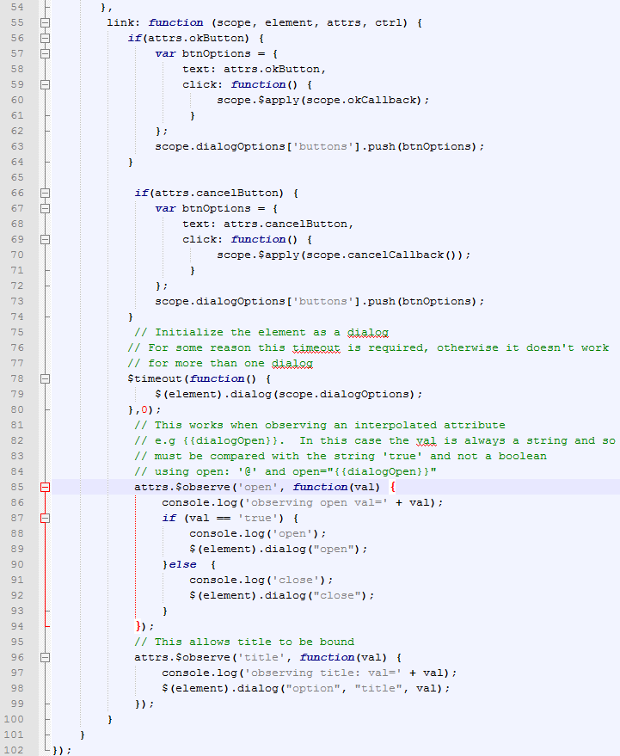

Code for the view (template)

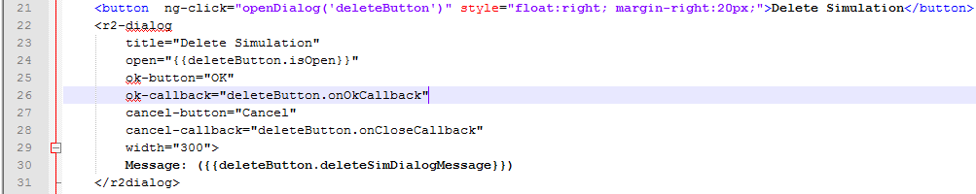

Code for the data in the controller

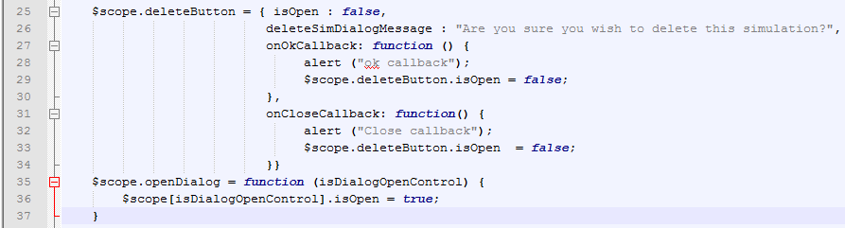

http://jan.varwig.org/archive/angularjs-views-vs-directives

https://github.com/angular/angular.js/wiki/Understanding-Scopes#JSproto

http://stackoverflow.com/questions/14994391/thinking-in-angularjs-if-i-have-a-jquery-background

http://adamalbrecht.com/2013/12/12/creating-a-simple-modal-dialog-directive-in-angular-js/

http://jsfiddle.net/theparabolink/dnCHA/

Backbone vs angular

http://blog.nebithi.com/backbone-and-angular-demystifying-the-myths/

http://www.infoq.com/articles/backbone-vs-angular

https://www.airpair.com/js/javascript-framework-comparison

https://connect.liveperson.com/community/developers/blog/2014/02/04/my-own-angle-on-angularjs--pros-and-cons

http://www.quora.com/What-are-the-advantages-of-Backbone-js

http://www.artandlogic.com/blog/2013/03/angularjs-for-jquery-developers/

https://www.ng-book.com/p/The-Digest-Loop-and-apply/

http://joelhooks.com/blog/2014/02/11/lets-make-full-ass-angularjs-directives/

http://www.joelhooks.com/blog/2013/07/27/using-angularjs-stop-using-jquery-as-a-crutch/

http://stackoverflow.com/questions/15676614/directive-link-vs-compile-vs-controller